System Requirements Statement (SRS)

The Vehicle Service Management System

Doc. Ref. : SRS_v0.4.doc

Version : 0.4

Status : Drafted

Created by : Kenji Tanaka

Date : 04-Dec-2012

1. Introduction 3

2. Functional Requirements 4

2.1 Customer Module 5

2.2 Service center Module 11

2.3 admin Module 16

2.4 Use Case Diagram..............................................................................................................................18

THIS DOCUMENT CONTAINS 19 NUMBERED PAGES

# Introduction

This document explains the system requirements and scope for developing The Vehicle Service Management System.

The Vehicle Service Management System could divide the three parts as Customer part, Service Centers part and Admin part.

This document describes the system requirement of the Account part.

# Functional Requirements

The Account part of The Vehicle Service Management System has three modules which are divided in 13 processes described as below.

|  |  |  |
| --- | --- | --- |
| **No** | **BRS requirement ID** | **Description** |
| **2.1** | **Customer Module** | |
| **2.1.1** | **F1** | **Registration Process** |
| **2.1.2** | **F2** | **Login Process** |
| **2.1.3** | **F3** | **Forgot Password Process** |
| **2.1.4** | **F4** | **Change Password Process** |
| **2.1.5** | **F5** | **Update Account Process** |
| **2.1.6** | **F6** | **Add Vehicle Information** |
| **2.1.7** | **F7** | **View Service Centers** |
| **2.1.8** | **F8** | **Book Service Slot** |
| **2.1.9** | **F9** | **Track Vehicle Service Progress** |
| **2.1.10** | **F10** | **View Past Service Records** |
| **2.1.11** | **F11** | **Give Ratings and Feedback** |
| **2.2** | **Service Center Module** | |
| **2.2.1** | **F12** | **Registration Process** |
| **2.2.2** | **F13** | **Login Process** |
| **2.2.3** | **F14** | **Forgot Password Process** |
| **2.2.4** | **F15** | **Change Password Process** |
| **2.2.5** | **F16** | **Update Account Process** |
| **2.2.6** | **F17** | **Upload Facility Information** |
| **2.2.7** | **F18** | **Upload Package Information** |
| **2.2.8** | **F19** | **Update Progress of Servicing** |
| **2.2.9** | **F20** | **View Ratings and feedback** |
| **2.2.10** | **F21** | **Raise Invoice** |
| **2.3 Admin Module** | | |
| **2.3.1** | **F22** | **Login Process** |
| **2.3.2** | **F23** | **Forgot Password Process** |
| **2.3.3** | **F24** | **Change Password Process** |
| **2.3.4** | **F25** | **Approve Service Center Registration** |
| **2.3.5** | **F26** | **View All Feedbacks** |
| **2.3.6** | **F27** | **Generate Report** |

# Customer Module

* Customer is the user of system who is looking for vehicle service facility.

# Registration Process

* The Vehicle Service Management System compels to create the account before booking the service slot. So, The Vehicle Service Management System should provide the function which makes customer create a new account.
* When customer creates a new account, the function demands following information.

1. Login information
2. Contact Details

* The Registration information

The Registration information consists of following items.

1. UserID
2. Password
3. First Name
4. Last Name
5. E-mail address
6. Date of Birth
7. User Type
   * All items are compulsory.
   * UserID

* The UserID should be unique. If the UserID already exists, then the UserID will not get registered due to its uniqueness.
  + Password
* The Password has constrains which makes the Password consists of more than or equal to 8 and less than or equal to 16 characters including characters described as below.

1. Numeric figure (at least one)
2. Capital alphabet (A-Z) (at least one)
3. Small alphabet (a-z) (at least one)
4. Special character (#, $, %, &, etc.) (at least one)
   * + The Password is masked by dummy characters. It is necessary to re-enter the Password.
   * User Type

The User Type falls into three categories described as below.

1. Customer
2. Service Center
3. Administrator

* The User Type defines also three types of users; "Customer user", "Service user", and "Administrator user”.
* In the Registration Process, the user can select “Customer”.
* No one could select The Administrator, because Administrator is implemented to The Vehicle Service Management System in advance.
* Contact Details
* The Contact Details consists of some items described as below.

1. Permanent Address
2. Contact Phone No
   * All items are compulsory.
   * Permanent Address

* Permanent Address should be filled.
* The Security Question information

The Security Question information is needed when the customer losses Password. This information consists of two items described as below.

1. Selected Question
2. Answer
   * All items are compulsory.
   * Some questions which are difficult to answer for anyone else are prepared in advance.

E.g., which color do you like most?

* + A question should be selected from options by the customer, and the Answer is registered by the customer.
  + After Successful registration an Account will be created for Service Center.

# Login Process

* The Vehicle Service Management System always compels user authentication before using itself except when a new account is successfully created.
* The user authentication demands UserID and Password. The UserID and the Password should be checked in two ways.
  + First, The UserID and the Password should exist and correct.
* If The UserID and the Password are not equal to what the user has registered, the user authentication cannot be provided.
  + Second, the User Type linked to the UserID should be "Customer".
* When the User Type is "Customer", then user can be placed on “Customer Home”.
* Only when the two checks are successfully completed, customer can be placed on “Customer Home” page.
* The “Customer Home” provides items described as below.

1. A trigger to logout
2. A trigger to update Account
3. A trigger to Change Password
4. A trigger to Add vehicle information
5. A trigger to view Service Centers
6. A trigger to Book Service Slot
7. A trigger to Track Service Progress
8. A trigger to View Past Service Records
9. A trigger to give Ratings and feedback

# Forgot Password Process

* When system user loses its Password, the recovery method should be provided by The Vehicle Service Management System.

The recovery method is described as below.

* + First, when user enters UserID for The Vehicle Service Management System.
  + Next, The Vehicle Service Management System demands the Answer which has been registered when the Account was created.
  + Only when the Answer is correct, customer will have to enter and re-enter a new password.
* The new password should consist of more than or equal to 8 and less than or equal to 16 characters including at least a numeric figure, a capital alphabet, a small alphabet, and a special character.
* As a consequence, the customer could get the customer authentication using the new password.
* If the Answer is not correct, then the correct Answer is demanded again from the customer.
  + In that case, customer couldn’t get the new password.

# Change Password Process

* When Customer wants to change their Password, the measure should be provided by The Vehicle Service Management System.
* Therefore, The Vehicle Service Management System should provide the function which is available after getting the customer authentication.
* The function demands the current password and the new password.
  + The new password should consist of more than or equal to 8 and less than or equal to 16 characters including at least a numeric figure, a capital alphabet, a small alphabet, and a special character.
  + The current password and the new password are masked by using dummy characters.
  + The new password is demanded to enter twice to avoid a typing error.
* Only when the current password is correct, customer could change the Password.
* When the current password is changed into new password, The Vehicle Service Management System compels user authentication again.

# Update Account Process

* The Vehicle Service Management provides the function which allows customer to update the account.
* The information could be updated is described as below.

1. Login information
2. User information
3. Security Question Information

* The Login information

The updatable items are described below.

1. First Name
2. Last Name
3. E-mail address
   * All items are compulsorily demanded, but updating is optional.

* The User information

The updatable items are described below.

1. User Name
2. User Phone Number
3. E-mail address
4. Permanent address
   * All items are compulsorily demanded, but updating is optional.

# Add Vehicle Information

* Vehicle Registration is required after login into the system.
* One customer can register many vehicles.

1. Vehicle Number
2. Brand
3. Model name
4. RTO Registration year.
5. Type of Fuel
6. Vehicle Running (km)

* All items are compulsory.
* Vehicle Number
  + Vehicle Number is constrained

1. First two letters should be Alphabets.
2. Next two letters should be numbers.
3. Next two letters should be Alphabets.
4. Next four letters should be numbers.

e.g., Vehicle Number is – MH13CN5962

* Brand
  + User is required to select brand from of available options.
* Model Name
  + User should select the vehicle model name from the available options.
* Registration Year
  + User should select the registration year of the vehicle.

# View Service Centers

* Customer can view details about registered Service Centers in the system.
* Customer can view offered service packages and standard rates.
* Customer could see details of Service Centers as follows -

1. Service Center name
2. Address
3. Offered Packages
4. Ratings

# Book Service Slot

* Customer can select the Service center.
* Customer can select the desired service package.
* Customer can view available Service slots based on date.
* After selecting above details customer can book a Service slot.

# Track Vehicle Service Progress

* After booking Customer can view the progress of servicing.

# View Past Service Records

* Customer can view Past Service Records of the vehicle.

# Give Ratings and Feedback

* Customer can register Ratings and feedback about the service facility.

# Service Centers Module

# Registration Process

* The Vehicle Service Management System compels Service Center to create the account before using it. So, The Vehicle Service Management System should provide the function which makes Service Center creates new account.
* When customer creates new account, the function demands three information as follows.

1. Login information

2.Contact Details

3.Security Question Information

* The Login information

The Login information consists of following items.

1.UserID

2.Password

3.Service Center Name

4.E-mail address

5.User Type

* + All items are compulsory.
  + UserID
* The UserID should be unique. If the UserID exists already, then it will not get registered once again due to its uniqueness.
  + Password
* The Password is constrained, which makes the Password consists of more than or equal to 8 and less than or equal to 16 characters including characters described as below.

1.Numeric figure (at least one)

2.Capital alphabet (A-Z) (at least one)

3.Small alphabet (a-z) (at least one)

4.Special character (#, $, %, &, etc.) (at least one)

* The Password is masked by dummy characters. It is necessary to re-enter the password.
  + User Type

The User Type falls into three categories described as below.

1.Customer

2. Service Center

3.Administrator

* The User Type defines also three types of users; " Customer user", "Service Center user", and "Administrator user”.
* In an Account Creation Process, the Service Center can select “Service Center” option.
* No one could select The Administrator, because Administrator is implemented to The Vehicle Service Management System in advance.
* Contact Details
* The Contact Details consists of following items.

1.Permanent Address

2.Contact Phone No

3.Email ID

* + All items are compulsory.
  + Permanent Address
* Permanent Address should be filled.
* The state should be selected from the options.
* The Security Question information

The Security Question information is needed when Service Center loses its Password. This information consists of following items.

* + 1. Selected Question
    2. Answer
  + All items are compulsory.
  + Some questions which are difficult to answer for anyone else are prepared in advance.

E.g., which color do you like most?

* + A question should be selected from options by the Service Center, and the Answer is registered by the Service Center.
  + After Successful registration an Account will be created for Service Center.

# Login Process

* The Vehicle Service Management System always compels Service Center authentication before using itself except when a new account is successfully created.
* The user authentication demands UserID and Password. The UserID and the Password should be checked in two ways.
  + First, The UserID and the Password should exist and correct.
* If The UserID and the Password are not equal to what the user has registered, the user authentication cannot be provided.
  + Second, the User Type linked to the UserID should be "Service Center".
* When the User Type is " Service Center ", user can be placed on “Service Center Home”.
* When the three checks get successfully completed, Service Centre get placed on the respected page.
* The “Service Center Home” provides items described below.

1. A trigger to logout
2. A trigger to update Account
3. A trigger to Change Password
4. A trigger to Upload Facility Information
5. A trigger to Upload Package information
6. A trigger to Update Progress of Servicing
7. A trigger to View Service Bookings
8. A trigger to View Ratings and feedback
9. A trigger to Raise Invoice

# Forgot Password Process

* When Service Center loses its Password, the recovery method should be provided by The Vehicle Service Management System.

The recovery method is described as below.

* + First, Service Center enters UserID for The Vehicle Service Management System.
  + Next, The Vehicle Service Management System demands the Answer which has been registered since when the Account was created.
  + Only when the Answer is correct, Service center will have to enter and re-enter a new password.
* The new password should consist of more than or equal to 8 and less than or equal to 16 characters including at least a numeric figure, a capital alphabet, a small alphabet, and a special character.
* As a consequence, The Service Center could get the user authentication using the new password.
  + Then, the Service Center better change the new password manually.
* If the Answer is not correct, the correct Answer is demanded for Service Centre again.
  + In that case Service Centre couldn’t get the new password.

# Change Password Process

* When Service Center wants to change account Password, the measure should be provided by The Vehicle Service Management System.
* The function demands the current password and the new password.
  + The new password should consist of more than or equal to 8 and less than or equal to 16 characters including at least a numeric figure, a capital alphabet, a small alphabet, and a special character.
  + The current password and the new password are masked by using dummy characters.
  + The new password is demanded to enter twice to avoid a typing error.
* Only when the current password is correct, Service Center could change their Password.
* When the current password is changed into new password, The Vehicle Service Management System compels Service Center authentication again.

# Update Account Process

* The Vehicle Service Management System provides the function which allows the Service Center to update his/her account.
* The information Service Center could update is described below.

1. Login information

2. User information

3. Security Question Information

* The Login information

The updatable items as described below.

1. Service Center Name

2. Contact Phone No.

3. E-mail address

* + All items are compulsory demanded, but updating is optional.
* The User information

The updatable items as described below.

1. User Name
2. User Phone No
3. E-mail address
4. Permanent address
   * All items are compulsory, but updating is optional.

* The Security Question information

The updatable items as described below.

1. Selected Question
2. Answer
   * All items are compulsory, but updating is optional.

# Upload Facility Information

• Service Centers can update information about their facilities.

1. Service Center name
2. Address
3. Offered Packages

# Upload Package Information

• Service Centers can update information about the offered service packages.

1. Package Name
2. Facility Details
3. Cost

# Update Progress of Servicing

* Service Center should provide information about the progress of servicing.
* Stages of servicing are -
  1. Vehicle check-in.
  2. Stage-I complete.
  3. Stage-II complete.
  4. Vehicle check-out.

# View Ratings and feedback

• Service Center should show Ratings and feedback submitted by the customers.

# Raise Invoice

• Based upon the details of the vehicle, an Invoice should get generate after checkout**.**

# Admin Module

**•** Administratorshould be responsible for following activities**.**

# Login Process

* The Vehicle Service Management System always compels user authentication before using itself, except when a new account is successfully created.
* The user authentication demands UserID and Password. The UserID and the Password should be checked in three ways.
  + First, The UserID and the Password should exist and be correct.
* If The UserID and the Password are not equal to what the admin has registered, the Admin authentication cannot be provided.
  + Second, the User Type linked to the UserID should be "Admin".
* When the User Type is "Admin", the user can be placed on “Admin Home”.
* When the two checks are successfully completed, Admin can be placed on the respective page.
* Items provided by “Admin Home” are as follows.

1. A trigger to logout
2. A trigger to Change Password
3. A trigger to View All Feedbacks
4. A trigger to Approve Service Center Registration
5. A trigger to Generate Reports

# Approve Service Center Registration

* Admin has authority to approve or disapprove the registration request raised by the Service center.

# View All Feedbacks

* Admin should able to view all feedbacks submitted by the system users.

# Record Generation

* Admin should generate Reports of total requests raised, Completed Tasks.

**2.4 Use Case Diagram**

**Customer:**

1. In Customer use case diagram Customer is an Actor.
2. Customer can handle following use cases:
3. Register
4. Login
5. Add Vehicle Information
6. View Service Centers
7. Book Service Slot
8. View Past Service Records
9. Give Ratings and feedback

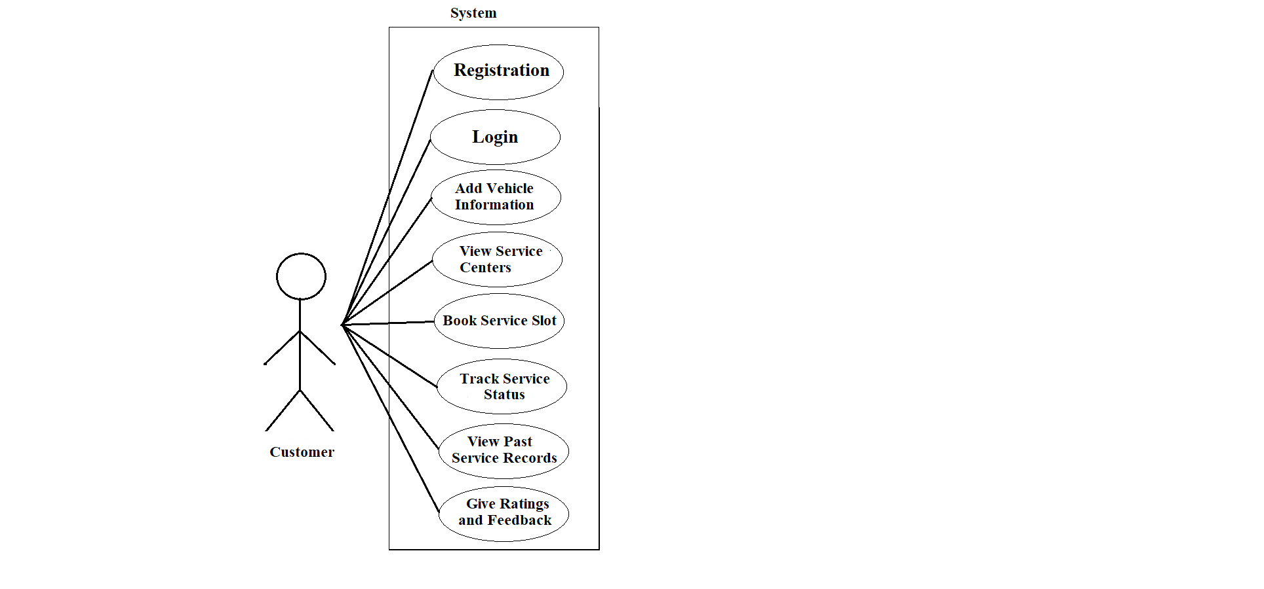

Figure 2. Use case diagram for Customer

**Service Center:**

1. In Service Center use case diagram Service Center is an Actor**.**
2. Service Center can handle following use cases:
3. Register
4. Login
5. Facility Information
6. Update Service Packages
7. Update Servicing Progress
8. View Ratings and feedback
9. Raise Invoice

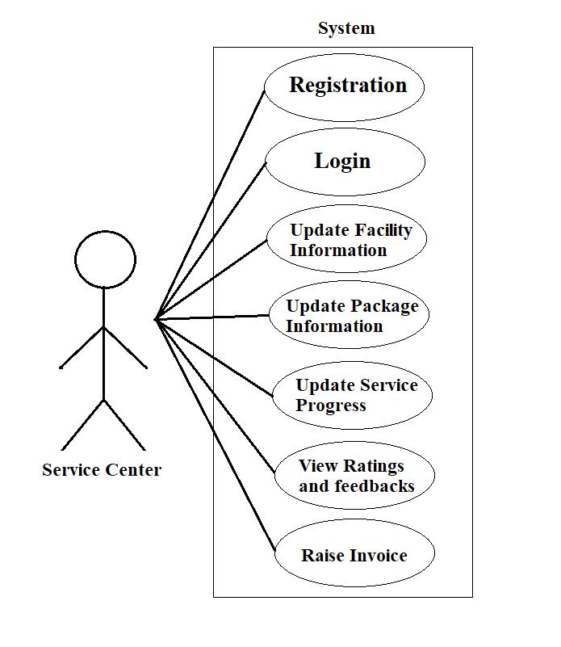

Figure 3. Use case diagram for Service Center

**Admin:**

1. In Admin use case diagram Admin is an Actor.
2. Admin can handle following use cases:
3. Login
4. View All Feedbacks
5. Approve Service Center Registration
6. Generate Reports

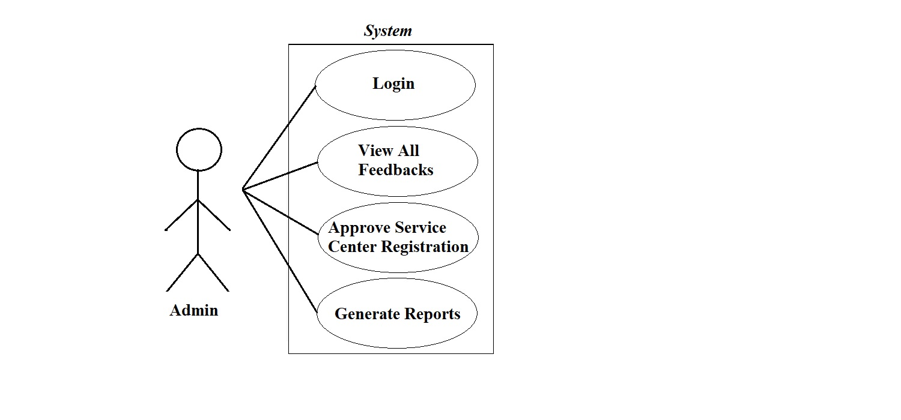

Figure 1. Use case diagram for Admin